

Domestic and Family Violence Policy

**Introduction**   
  
Lighthouse Church is about loving and honouring God by making lots of deep disciples. Included in this, we desire to be a safe and loving church that wants to strengthen and love families.

This policy aims to protect and promote the safety and well-being of members and regular attendees of Lighthouse Church. It expresses our condemnation of violence in families, in church and society, and outlines how we respond to incidents of domestic violence with sensitivity, fairness, and love.

Domestic and family violence refers to behaviour that is threatening, violent or abusive, designed to exert power and control over a person, or cause a person to be fearful in a family or intimate relationship or following a relationship. This can include verbal, physiological, physical, sexual, or financial abuse including neglect.

After 1 July 2024, behaviour considered to be ‘[coercive control](https://dcj.nsw.gov.au/children-and-families/family-domestic-and-sexual-violence/about-domestic-and-family-violence/coercive-control/coercive-control-english.html#:~:text=From%201%20July%202024%2C%20coercive%20control%20is%20a,abusive%20behaviour%20that%20happens%20after%201%20July%202024.)’ will be a criminal offence in NSW where a person uses behaviour towards a current or former intimate partner with the intention of coercing or controlling them where a reasonable person would consider the conduct likely to cause fear that violence will be used on a person, or a serious adverse impact on the person’s capacity to engage in ordinary day-to-day activities.

**Policy   
  
Creating a safe and loving church**

Lighthouse Church is committed to being a safe and loving church that:

* Promotes a culture of healthy relationships of mutual responsibility and respect in marriages, families, and the church community.
* Recognises domestic violence is contrary to the bible’s teachings of mutual love and care in marriage and in the home, is not acceptable conduct for disciples of the Lord Jesus, does not meet our beliefs and Code of Conduct, and may be a crime.
* Does not condone, justify, tolerate, overlook or conceal any form of abuse.
* Ensures our staff, leaders and ministry workers undertake training in recognising and responding to abuse, including domestic violence.
* Aims to ensure all people are welcomed, respected, and safe in church.
* Enables domestic violence concerns to be raised and responded to clearly, consistently and confidentially.
* Strives to follow good practice in protecting and supporting people experiencing or affected by family violence.

**Responding to domestic violence**

Where Lighthouse Church becomes aware of an instance of domestic violence within our church community we will:

* Ensure a person’s disclosure of domestic violence and their experiences are taken seriously.
* Ensure people affected by domestic violence are supported to ensure immediate safety and wellbeing as a first priority.
* Recognise that sometimes our role may just be to listen. We will encourage and support people to take action, but generally we will be led by the person themselves about the action that should be taken.
* Clearly explain as early as possible the mandatory reporting obligations that must be followed if children are involved or exposed to domestic violence.
* Encourage and support those affected to access appropriate professional advice from those who understand and know what supports are available and accessible.
* Encourage the person affected to let a Lighthouse pastor know of their situation, or give consent for the person they have shared their situation with to do this.
* If consent is given, a Lighthouse pastor will speak to the person affected to make a plan that prioritises the safety and support of the person involved. They will also make a plan of action in relation to the person who has or is acting unacceptably or violently, particularly if they are involved in church and/or ministry at Lighthouse Church.
* Ensure our staff, leaders and ministry representatives respect the need for confidentiality.
* Work with relevant authorities during any investigation into domestic violence.

**Procedures**

**In an emergency**

Prioritise safety. If you or your family are in an unsafe situation, first take action. Consider leaving the immediate situation or location, phoning emergency services on 000, or phoning someone in church you trust for immediate help.   
  
The same applies if someone phones you for help. Firstly confirm if there is an immediate risk to the safety of the person or their family. If there is, encourage them to take action as outlined above.

**If you are affected by domestic violence**

You can talk to someone in church you trust about your situation and, if you feel ready, you can ask for help or support from church. Consider talking to your growth group leader, ministry leader, safe ministry representative, or staff.

Information you share will be treated sensitively and carefully. You may just want to talk through your situation with someone. We will be led by you to understand how we can help and support you and your family.

People in church will use the information below to guide them in how to help and support you. You can use the information below too if you want to access resources and support yourself.

It is important that you understand that if children are affected by domestic violence Lighthouse staff (paid employees) may have an obligation to notify relevant authorities. There are other situations where it might be necessary to take action within church. You can read more about this in the information below.

**Responding to domestic violence**

The following five ‘R’s form the basis of our procedures for responding to domestic violence.

1. **Recognise the signs**

Our safe ministry training includes known indicators of abuse and responding appropriately to a disclosure of abuse, particularly in the context of children’s/youth ministry. Refer to LC04 Policy and Procedure - Serving in children's and youth ministry.

In the context of family violence, the following signs can be an indicator of abuse:

* persistently telling a person they ‘never do anything right’
* insulting, demeaning or shaming in front of other people
* isolating a person from family and friends and/or extreme jealousy of time spent with other people
* preventing a person making their own decisions
* monitoring or tracking a person’s movement, activities, or communications without their permission
* controlling finances in the household without discussion including taking money and/or refusing to provide money for necessary expenses
* pressuring a person to engage in behaviour the person is not comfortable with
* intimidation or physical threats either in words or actions
* threatening to harm or take away children or pets, or things of value
* destroying belongings or the home[1].

1. **Respond**

It is likely conversations about instances of family violence will come as a disclosure from the person affected. This may be as a result of you asking if they are OK, or it may be instigated by the person affected either because of your pre-existing relationship, or because they are ready to ask for help.

It takes courage to disclose an experience of family violence. You don’t have to be an expert to assist someone in this situation. Responding sensitively and with compassion is an important part of supporting the person who makes a disclosure. Simply listening and responding with compassion can help the person feel safe and believed which may positively contribute to their decision to access support.

The following provides a good guide for responding well:

* If possible, suggest moving to a quiet room or space where the person can talk freely.
* Take time to listen to what the person wants to share with you.
* Respond calmly and with compassion.
* Avoid asking questions unless absolutely necessary.
* Do not argue or justify or push any other agenda.
* Validate that the violence is not OK and not their fault.
* Thank the person for trusting you with this information and ask what they would like from you to support their safety.
* Respect their right of control over what they say and the actions they may want to take.

At some point it will be necessary to raise the question of immediate safety for the person and other family members if relevant.

This often provides a natural transition point to discussion about current supports and consider services of supports the person might feel comfortable accessing.

1. **Refer for support**

It is important to know your role in the conversation is not to jump to problem-solving or to have all the answers. This conversation should be led by the person making the disclosure as they are well placed to understand the complex details of the situation.

You can ask what support they have now, and what other specialist assistance they might feel comfortable accessing. You don’t have to have a lot of knowledge at this stage to help.

A good starting point for professional help is the [1800RESPECT website](https://www.1800respect.org.au/) funded by the Australian Government operating 24 hours, 7 days a week providing free support by trained counsellors for people impacted by family violence. The website enables people to make contact in whatever way they feel comfortable - via phone, text, online video or chat, or by accessing advice from the website.

If a person chooses to phone, they will be able to talk to a trained counsellor who will listen, be guided by them, and work with the person to help identify what they can do and to find the right services or support for them and their specific situation.

1. **Required actions**

As a general principle we will not take any action without the consent of the person affected, however there are times where action is required regardless of consent. This includes:

* if there are reports or evidence of children (or other vulnerable people[2]) being involved in or exposed to (witnessing) domestic violence
* there is an immediate and significant threat to the safety of the person/people involved, or the person who has or is acting unacceptably or violently (eg reasonable belief of intention to self harm)[3].

In the above situations, it is very important to advise the person of mandatory reporting requirements as early as possible in conversation.

In addition to actions required by law, there may be actions that are necessary in line with LIghthouse Church policies and procedures, codes of conduct and employment conditions. These include:

* With the consent of the person affected, and if safe and appropriate, the person who has acted unacceptably will be encouraged to meet with staff to discuss the situation, identify appropriate supports and action in church, and to access professional help and support as necessary.
* A written action plan that is tailored based on the family, the specifics of the situation (eg the extent of the behaviour concerned, whether the person recognises their behaviour is unacceptable), the person’s role in church[4], and any other directions from authorities will be developed.
* Any staff member acting unacceptably or violently is in breach of Lighthouse beliefs and Code of Conduct, and action will be taken in line with their employment letter of offer with appropriate external advice and support.

The flow chart in Appendix 1 is designed to guide reporting considerations.  
  
The priority will always be ensuring the safety and well being of people affected by domestic violence. However, the person who has acted unacceptably may also require assistance and support. It is desirable that where possible and appropriate family relationships are maintained and/or restored.

1. **Record keeping**

It is necessary for staff leaders, safe ministry representatives, and leaders in church who are involved in receiving a report of, or responding to, domestic violence to take and maintain a comprehensive written record of relevant conversations, plans of action, and action taken.   
  
Records should be made as close as possible (same day) to the conversation, incident, or action. Records may be requested by authorities if there is any investigation or action taken. Records must be filed and maintained with the highest level of security recognising the risk to a person’s safety as well as their privacy.

**Review**

This policy and procedure will be reviewed at least annually or as required depending on external requirements, and internal considerations or needs.

**Questions or concerns**

You can email [safeministry@lighthouse.net.au](mailto:safeministry@lighthouse.net.au) if you attend Lighthouse Church and have questions or concerns relating to this policy and procedure, or in relation to domestic violence.

**Related policies and procedures**

* LC01 Policy and procedure - privacy and information management
* LC03 Policy and procedures - managing child safety in church
* LC04 Policy and procedures - serving in children’s and youth ministry.

**Appendix 1 - Flowchart to guide responding to domestic violence** 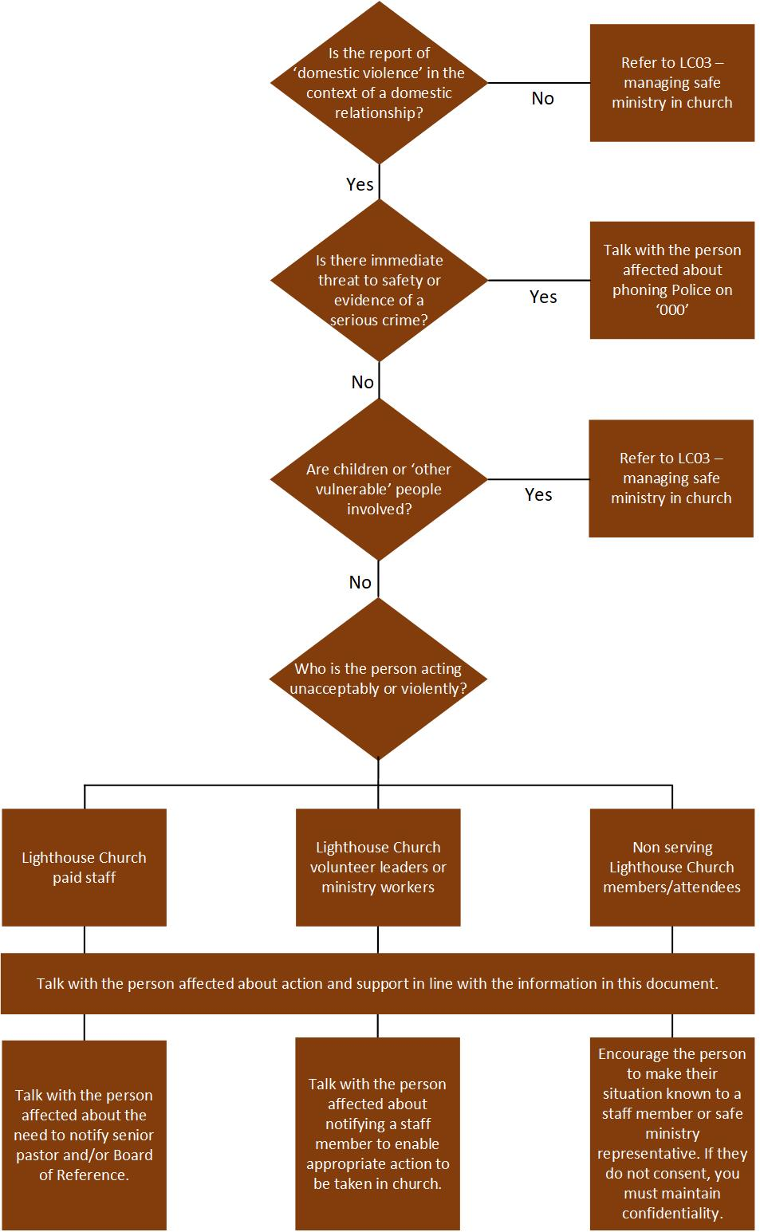

**Appendix 2 - Key contacts**

|  |  |
| --- | --- |
| **1800 Respect National Helpline**  24-hour national number for sexual assault, family violence counselling and advice | 1800 737 723  1800respect.org.au |
| **Daisy App**    Connects people who may experience family violence or abuse to support services in their local area | Free to download from iPhone App Store & Android Google Play |
| **Child Protection Helpline**  Anyone can contact this helpline if you think a child or young person is at risk of harm from abuse.  At LIghthouse we have a procedure (LC03) for responding to and reporting:   * reportable conduct by a person performing work for Lighthouse Church (reportable conduct scheme) * concerns about risk of harm or abuse of a child. | 13 21 11  Report directly to the senior pastor or a safe ministry representative. |
| **Lifeline**  24-hour telephone crisis line for anyone experiencing emotional distress. | 131 114  lifeline.org.au/get-help |
| **No To Violence: Men’s Referral Service** Telephone counselling, information and referral service for men using violence in families. | 1300 766 491  ntv.org.au |
| **Police**  24-hour emergency line where safety is at immediate risk | 000 |
| **Safe Ministry at Lighthouse**  Use this email to let church know of any concerns or questions you have about safety at Lighthouse Church. | safeministry@lighthouse.net.au |

1. [National Domestic Violence Hotline](https://www.thehotline.org/identify-abuse/domestic-abuse-warning-signs/) and [Coercive Control](https://dcj.nsw.gov.au/children-and-families/family-domestic-and-sexual-violence/about-domestic-and-family-violence/coercive-control/coercive-control-english.html#:~:text=From%201%20July%202024%2C%20coercive%20control%20is%20a,abusive%20behaviour%20that%20happens%20after%201%20July%202024.), NSW Government Communities & Justice.
2. Vulnerable people include children and people over 18 years who may be less able to care or defend themselves,   
    and/or protect themselves against harm or exploitation.
3. Under the Crime Act a person must report a serious crime to the Police unless they have a ‘reasonable excuse’   
    which may be evidence to support the belief that the information is already known to Police, a report has been made  
    to another government authority (e.g. Office of the Children’s Guardian), or the person affected is an adult with   
    decision making capacity who does not want information to be reported to Police (section 316, Crimes Act 1900).
4. If the person has a leadership role or serves in ministry in church, this is likely to involve stepping down from ministry.